A000-Eur-France-Montastruc-Tarn et_Garonne-Figurine-Mammoth-Late Magdalenian-ca 12,500 BP.



Fig. 1. France-Montastruc-Tarn­_et_Garonne-Figurine-Mammoth-Late Magdalenian-ca 12,500 BP. L 124 mm. Original. Photo: Johnbod. Permission: Creative Commons Attribution-Share Alike 3.0 Unported license.



Fig. 2. France-Montastruc-Tarn­_et_Garonne-Figurine-Mammoth-Late Magdalenian-ca 12,500 BP

Reconstructed atlatl effigy in the shape of a woolly mammoth made from Pleistocene reindeer (*Rangifer tarandus*) antler. Length of effigy, 124 mm, replica in resin. Note the reconstructed placement of the atlatl barb at the rear of the animal like excrement. The carvers of these effigies had a great sense of humor with placing the atlatl barbs.



Figs. 3. France-Montastruc-Tarn­_et_Garonne-Figurine-Mammoth-Late Magdalenian-ca 12,500 BP. Reconstructed atlatl effigy in the shape of a woolly mammoth (with its reconstructed barb or peg) affixed to a reconstructed single piece of Pleistocene reindeer (*Rangifer tarandus*) antler.

Case No.: 1



Fig. 4. Atlatl with a Pleistocene chamois (*Rupicapra rupicapra* Linnaeus 1758) effigy from Le Mas d'Azil, Ariège, Late Magdalenian-ca 12,500 BP, and its attached atlatl shaft and atlatl barb or peg carved from a single piece of Pleistocene reindeer (*Rangifer tarandus*) antler. Note the placement of the atlatl barb or peg as though being the afterbirth of the animal or its excrement with a bird figure looking at the animal from that location.



Fig. 5. Reconstructed atlatl with an effigy in the shape of Przewalski's horse (*Equus ferus przewalskii*) from Grotte de Bruniquel (28 cm) and attached to a reconstructed single piece of Pleistocene reindeer (*Rangifer tarandus*) antler. Note the reconstructed placement of the atlatl barb or peg as though being the penis of the animal and affixed to a single piece of Pleistocene reindeer (*Rangifer tarandus*) antler. From Donsmaps.com



Fig. 6. Reconstructed atlatl with an effigy in the shape of a Pleistocene hyena (*Crocuta crocuta spelaea*, Goldfuss 1823), with barb or peg attached and affixed to a reconstructed single piece of Pleistocene reindeer (*Rangifer tarandus*) antler. La Madeleine, Dordogne, France. From Donsmaps.com

  
Fig. 7. Reconstructed atlatl with an effigy in the shape of two Pleistocene ibexes (minus their horns) from Les Trois-frères, Magdalenian, 14,000 BP-13,000 BP, (H 6 cm, of the effigy), with barb or peg attached, and the effigy affixed to a reconstructed single piece of Pleistocene reindeer (*Rangifer tarandus*) antler. Effigy from http://www.studyblue.com/notes/note/n/arth-1450-exam-1/deck/2128191



Fig. 8. Reconstructed atlatl with an effigy in the shape of a Pleistocene bison licking its shoulder, La Madeleine, Dordogne, France. From Donsmaps.com



Fig. 9. Reconstructed atlatl with an effigy in the shape of a Pleistocene bison. La Madeleine, Dordogne, France. From Donsmaps.com

**Formal Label:** Eur-France-Montastruc-Tarn­_et_Garonne-Figurine-Mammoth-Late Magdalenian-ca 12,500 BP.

**Display Description: This** atlatl effigy, which is dated ca 14,000 BP-13,000 BP to the Late Magdalenian, Upper Paleolithic period, is in the shape of a woolly mammoth. It was made from a Pleistocene reindeer (*Rangifer tarandus*) antler. It was excavated by Edouard Lartet and Henry Christy in 1863 in Montastruc, Tarn-et-Garonne, Midi-Pyrénées, France, on the northern bank of the River Aveyron, a tributary of the Tarn River. It has been reconstructed here with the placement of its atlatl barb or peg at the rear of the animal like excrement and with its lost atlatl shaft.

**Accession Number:**

**LC Classification:** GN772.2.M6

**Date or Time Horizon:** 14,000 BP-13,000 BP

**Geographical Area:** Montastruc, Tarn-et-Garonne, Midi-Pyrénées, France.

**Map, GPS Coordinates:** 44.102958; 1.291760.

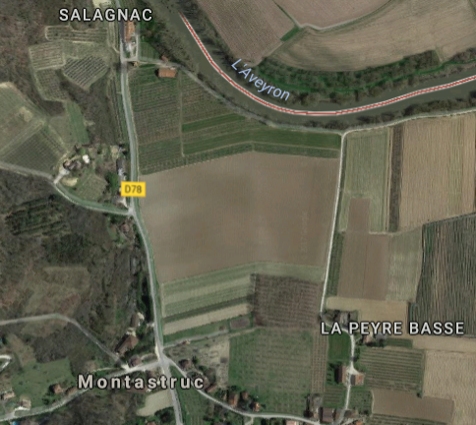

Fig. 10. Map of Montastruc, Tarn-et-Garonne, Midi-Pyrénées and River Aveyron, France.



Fig. 11. Map of the caves in the Midi-Pyrénées, France, area after Jaubert et alii, 2016.

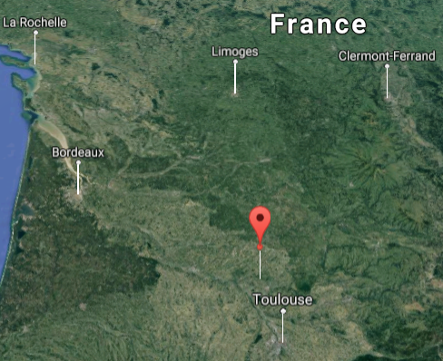

Fig. 12. Location of the caves in the Tarn-et-Garonne, Midi-Pyrénées, France, area from <https://www.google.com/maps>

**Cultural Affiliation:** Late Magdalenian, Upper Paleolithic period.

**Medium:** mammoth ivory.

**Dimensions: L 124 mm.  
Weight: original, not known.**

**Provenance: British Museum, Christie Collection.**

**Condition:** museum replica in resin.

**Discussion:**

Carvers of these effigies had a great sense of humor with placing the atlatl barbs as is exemplified in the Figs. 3-8, which came from the same area in France. The correct placement of the lost atlatl barbs or pegs is crucial to an interpretation of how the effigy of the animal was envisioned.

The discoverers of this atlatl effigy, Lartet and Christie, were able to establish and document the stratification of mobilary art or portable objects such as these carved antler atlatl shafts.Édouard Lartet (15 April 1801 – 28 January 1871) was a geologist, paleontologist, and a Paleolithic archaeologist who made important discoveries in the Abri de la Madeleine and Le Moustier, which provided type-sites for archaic stone-age cultures. Christie (26 July 1810 – 4 May 1865) was a Quaker philanthropist and amateur archaeologist who was actively involved in the Ethnological Society of London, the Anthropological Society of London, the Linnaean Society, the Geological Society, the Royal Geographical Society, and was a Fellow of the Society of Antiquaries of London. He left his substantial archaeological collections to the British Museum of which this effigy is a part.

**References:**

1. Bétirac, B. 1952. “L'abri Montastruc à Bruniquel (Tarn-et-Garonne),” *L'Anthropologie,* 56(3-4): 213-231.
2. Chisholm, Hugh, ed. 1911. “Lartet, Edouard,” Encyclopædia Britannica (11th ed.). Cambridge: Cambridge University Press.
3. Jaubert, J*.* Verheyden, SophieVerheyden, Dominique Genty, Michel Soulier, Hai Cheng, Dominique Blamart, Christian Burlet, Hubert Camus, Serge Delaby, Damien Deldicque, R. Lawrence Edwards, Catherine Ferrier, François Lacrampe-Cuyaubère, François Lévêque, Frédéric Maksud, Pascal Mora, Xavier Muth, Édouard Régnier, Jean-Noël Rouzaud, Frédéric Santos*.* 2016. “Early Neanderthal constructions deep in Bruniquel Cave in southwestern France,” *Nature*, 534 (7605): 111-114.
4. Ladier, Edmée, Anne-Catherine Welté, Georges Lambert. 1994. “Les objets de parure de la vallée de l'Aveyron, Le Courbet, Bruniquel-Montastruc et autres abris; documents inédits ou retrouvés,” Paléo, 6: 197-231.
5. Marshack, A**.** 1972. *The Roots of Civilization: The Cognitive Beginning of Man’s First Art, Symbol and Notation.* New York: McGraw-Hill.
6. Welté Anne-Catherine. 2002. “L'art mobilier magdalénien de Fontalès (Tarn-et-Caronne) dans la vallée de l'Aveyron: les représentations anthropomorphes et zoomorphes,” Bulletin de la Société préhistorique française, 99(3): 624-626.